1：Clean cookies

2：Clean temporary file

3：Random 0-15 seconds waiting

4：use mysql get proxy port and change proxy port status
SELECT us_port
FROM us_port
WHERE status IN (0)

UPDATE us_port
SET
status='1'

5： change browser fingerprint

6：open url http://publishdream.com
7：open url http://lumtest.com/myip.json get proxy ip ，state
8：set offername offerAdvertisers
9：Check if IP is duplicate（31day）
SELECT count(*) FROM history WHERE IP='{-Variable.PROXYIP-}' AND TIMESTAMPDIFF(day,Time,now())<'31' AND (Advertisers='{-Variable.Advertisers-}' OR OfferName='{-Variable.Offername-}');
If = 0
Add proxy ip to mysql
~~~~~~~~~~~~~~~~~~~~~~~~~~~~~~~~~~~~~~~~~~~~~~~~~~~~~~~~~~~~~~~~~~~~~~~~~~~~~~~~~~~~~~
INSERT INTO history

(Advertisers,Offername,IP,Time)

values ('{-Variable.Advertisers-}','{-Variable.Offername-}','{-Variable.PROXYIP-}','{-Variable.Time-}')
If = 1
Go to 6. Try 4 times.

10 open offer url (https://www.123cashnow.com/)

Get domain
If domain = www.123cashnow.com go to 11
Else
Go to 10 try Try 4 times.

11
Get data for mysql and excel to variable

Mysql

SELECT Data_ID ,First_Name ,Last_Name ,Email ,Phone ,Address ,City ,State ,Zip ,YY ,MM ,DD ,Mobile ,Rent_or_Own ,Employer ,Job_Title ,Work_Phone ,Pay_Frequency ,Monthly_Income ,SSN ,License_No ,License_State ,Bank_Name ,Bank_Account ,Routing_No ,Loan_Amount ,status5
FROM us_data
WHERE status5 IN (0)
ORDER BY Data_ID LIMIT 1;

UPDATE us_data status5
SET
status5='1'
WHERE Data_ID='{-Variable.Data_ID-}'
~~~~~~~~~~~~~~~~~~~~~~~~~~~~~~~~~~~~~~~~~~~~~~~~~~~~~~~~~~

12
Use get data ，input to website
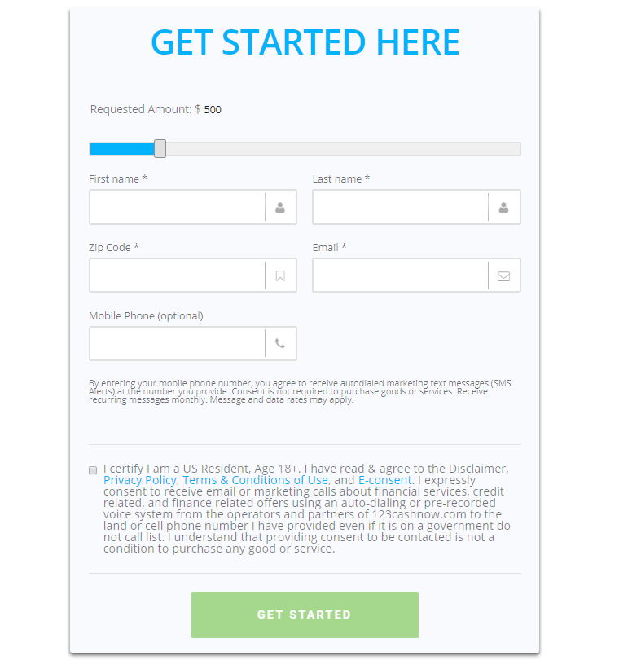
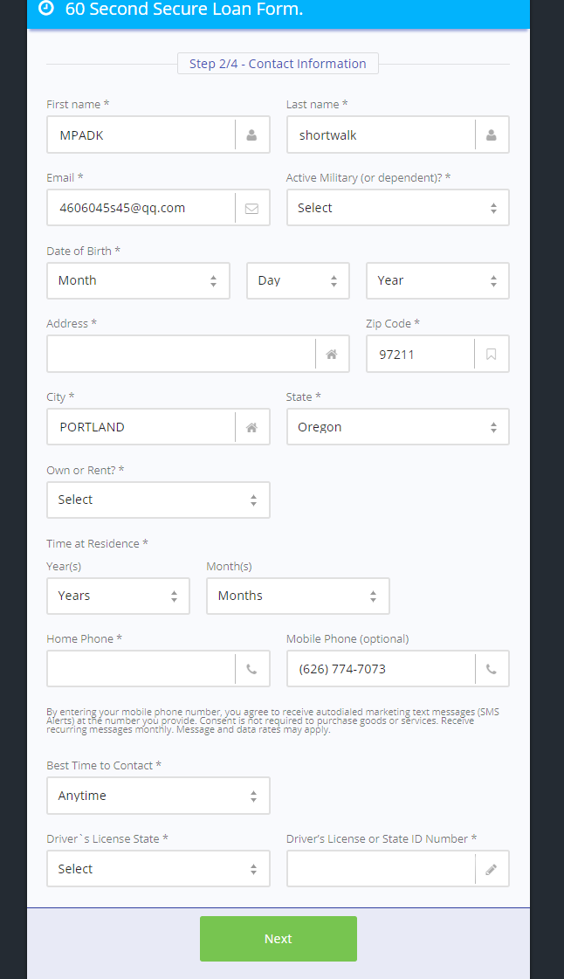
Submit 4 page
13
Wait 30 seconds
Get domain
If domain = www.123cashnow.com go to 13. Try 20 times
domain = www.redirectlead.com go to 13. Try 20 times
domain = contract.nationalsmallloan.com go to 13. Try 20 times
domain = inbox-credit-cache.vertical.arbcalls.com go to 13. Try 20 times

domain = account.zocaloans.com go to 13. Try 20 times

domain = csl.monevo.us go to 13. Try 20 times
else：
exit

END

